**DEFENCE FOOD RESEARCH LABORATORY**

**TEJASHWINI D**

**III BSc (D section)**

**U01AG21SO728**

**R BRITTO DOMINIC RAYAN**

**Department of chemistry**

**MSCW, Mysore**

**2023-24**

**MAHARANIS’ SCIENCE COLLEGE FOR WOMEN**

**Jhansi Rani Lakshmi Bai Road, Mysore**

**Karnataka -570005**



Government of Karnataka

Department of Collegiate Education

**Maharani’s Science College for Women (Autonomous), Mysuru**

(RE-ACCREDITED BY NAAC “A” GRADE)

**Department of Chemistry**

Date:08-05-2024

**CERTIFICATE**

This is to certify that the internship entitled **“DEFENCE FOOD RESEARCH LABORATORY**” was successfully carried out by **TEJASHWINI D**, a bonifide students of VI semester towards the partial fulfilment for the Bachelors of Degree (B.Sc.) during the year 2023-24. All the corrections/suggestions indicated have been incorporated in the report. The internship report has been approved as it satisfies the requirement in respect of internship work prescribed for the said degree.

Faculty In charge Head

Department of Chemistry

**DECLARATION**

I, the under mentioned, solemnly declare that this internship report on **“DEFENCE FOOD RESEARCH LABORATORY”** is submitted to the Department of Chemistry, Maharani’s Science College for Women (Autonomous), Mysuru in partial fulfilment of the requirements of the degree of Bachelor of Science. Further, I hereby, declare that this internship report is based on my observations, learning and experience that I gained during the internship. This internship report, neither in whole, nor in part, has been previously submitted for any degree.

Date:08-05-2024 Signature of the student

Place: Mysore …………………………

III B.Sc. ‘D’ section

MSCW, Mysuru

**CONTENTS**

|  |  |
| --- | --- |
| **SI NO** | **CONTENTS** |
| 1 | Aim and objectives |
| 2 | Introduction |
| 3 | Achievements |
| 4 | Supplies to armed forces |
| 5 | Detection kits |
| 6 | Biodegradable cutlery |
| 7 | Mobile BSL 3 laboratory |
| 8 | Pre-cut and packaged vegetables |
| 9 | Hurdle technology |
| 10 | Ready to drink juices |
| 11 | Ready to constitute food products |
| 12 | Ready to eat chapati and paratha |
| 13 | Ready to eat bars |
| 14 | Rations for armed forces |
| 15 | Ready to defence forces |
| 16 | Conclusion |

**AIM AND OBJECTIVES OF INTERNSHIP**

**AIM**

Internship gives us a learning experience with well-defined goals that facilitates cross disciplinary learning, development of new skill, integrated knowledge to the students. The employability of graduates can be improved by developing practical experience and exposure with the required right kind of attitude for the workplace. The Internship is one of the important apparatuses that help in improving these employability skills and can help in generating competency, capability, professional working skill, expertise, and confidence among the students for employability and developing interest or passion for research. The intersect can understand the application of the theory in workplace.

The Internship programs should be well conceptualized and interactive for building skills of the students for:

1. Development of project and its execution
2. Decisions making
3. Confidence development
4. Working or coordinating in a team
5. Creative and critical thinking and problem solving
6. Ethical values
7. Professional development
8. Understand government or local bodies world of work
9. Reference pf resource persons in the field
10. Development of an online simulation-based module for a virtual research internship
11. Understanding the strategies of building a deep technology start up
12. Study certain entrepreneurs

**OBJECTIVES**

An internship is gaining first hand experienced by an individual besides comprehending the way of working in an organisation, leading to improvement of the skill aptitude for a specific job or job role and building research capabilities with learning opportunities. Internship should be so organised that they benefit the research intern as well as the internship providing organization.

* Integration of workshop with workplace: To see the internship in a broader, Integrated and holistic manner where the delivery of the classroom is aligned with outcomes of the workplace.
* Understanding of the world: To provide undergraduate students with an opportunity to improve their understanding experience.
* Physical and hybrid model learning: To broaden learning opportunities by combining physical and digital modes of learning while working in industry, corporate, research and development organisations, workplace.
* Developing research aptitude: To create and facilitate conditions that allow students in their quest for knowledge, its discovery, learn, understand and sharpen research acumen, familiarizing with analytical tools and techniques.
* Exposure to emerging technologies: To provide exposure to emerging technologies or automation and how it can support, facilitate, improve and reinforce work process or culture, job roles etc.
* Enhance entrepreneurial capabilities: Understand how organizations or enterprises are formed for sustainable progress so that start-ups and entrepreneurial capabilities are strengthened among students, and they are encouraged to be job creators.
* Development of decision making and teamwork skills: To facilitates the development of problem solving and decision-making skills, enable teamwork and collaborations.
* Cultivate a sense of social imagery and citizenship responsibility: To develop a sense of social imagery and philanthropic versatility among the graduating students.
* Enhancing professional competency; The internship should not only focus on employability on research capability, there is also a need for professional principles, ethics, values and integrity which enable them to gain perspective, practice, develop as competency and perform professional tasks in the way that the employment market demands.

As part of our syllabus, we have internship program visited to DFRL on 23-04-2024.

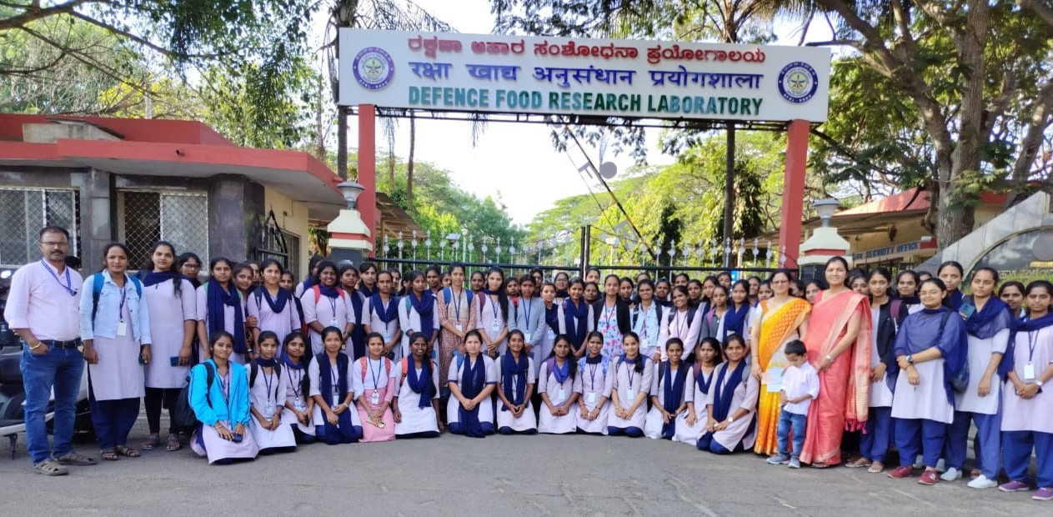

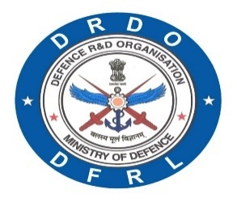

DFRL PRODUCTS AND TECHNOLOGIES

**DEFENCE FOOD RESEARCH LABORATORY** DEFENCE RESEARCH & DEVELOPMENT ORGANIZATION

MINISTRY OF DEFENCE

**INTRODUCTION**

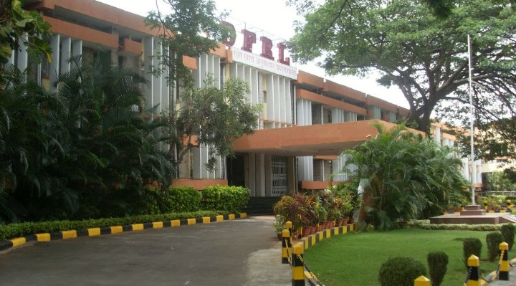

Defence food Research Laboratory(DFRL) was established at Mysore in December 1961 under the ages of Defence Research and Development Organization (DRDO),Ministry of Defense (MOD),Government of India (GOI) to conduct research and development (R&D) in the area of advanced food science and technologies for mission platform, terrain, and weapon-specific combat rations and state of the art food packaging technologies for all environments in order to meet the strategic operational requirements of the Army, Navy, Air force and Paramilitary force.

In the six decades of its existence, DFRL has established itself as a national premier institute in the field of combat ration and convenience food development, field amenable test kits, packaging materials for extreme environmental conditions, and critical missions such as the space mission, Antarctica mission, etc.

DFRL is a Centre of excellence for food presentation, packaging, food specifications, food analysis, victual support system, life sustenance system and human resource development.

With consistent efforts over the years, DFRL has developed process technologies and novel packaging technologies for the preservation of multi-entrée desi food with a shelf life of 19-16 months in any weather.

These products offer exceptional convenience to troops and consumers and are either ready-to-eat (RTE) or ready-to-reconstitute (RTR) forms.

Many of the technologies developed by DFRL for the preservation of food, test kits to check the quality of the food, and packaging materials an based on state-of-the-art technologies from indigenous sources.

The Defence food Research laboratory (DFRL) is an Indian Laboratory of the Defence Research and Development Organization (DRDO). Located at Mysore, Karnataka. Conduct research and development of technologies and products in the area of food and technology to cater the varied food challenges for the Inian Armed forces. DFRL is organized under the life sciences directorate of DRDO. The present director of DFRL is Dr. Anil Dutt Semwal.

**“DFRL, IN THE SERVICE OF THE NATION”**

**VISION**

To be a technology leader of excellence in food research and development.

**MISSION**

Design, develop and evaluate; safe, nutritious and convenience food to meet the needs of services and spin-off to civil applications.

**CORE COMPETENCE**

Development of convenience and ready-to-eat food products and implementation of packaging systems and processing technologies for fresh and processed food, testing and evaluation of food.

**ACHIEVEMENTS OF DFRL**

* “National science Day Award 2019” for ‘Nano thermal Food Processing Technologies’.
* “National Technology Day Award 2019” for ‘Recent Technology on Post Harvest Management’.
* Technology Spin Award-2017
* For best Scientific Lab-2013
* Titanium Trophy-1984 for Developing innovative technologies for convenience foods, food preservation and processing safety foods.
* Best Poster Award from ‘ICFOST-2016’ Entitle “Development of flax seed extract incorporated curd powder on anti- chromic mild stress properties”.
* “National science Day Award” for ‘Application of carbon Materials in Advanced Technologies” on 2015.
* “Kejriwal award” for ‘Development of value-added products from jackfruit for small and medium enterprises’ on 2014.
* “Spruthi Award” for ‘Stabilization of ready-to-eat coconut chutney using combination processing technology’ on 2014.

Patents Granted-89

Patents Failed-220

**Publications:**

International journal-538

National journal-466

Book chapter-216

**SUPPLIES TO ARMED FORCES**

**MRE RATION TECHNOLOGY:**

Army, Navy, PMO.

The development of Pack Rations to services Forces.

This technology used is highly scientifically accepted at international level.

**SURVIVAL RATION:**

DFRL developed Survival Ration comprising energy dense soft bar and chikkis from groundnut with jaggery/sugar to meet immediate nutritional requirements of Armed Forces during operations.

**EMERGENCY FLYING RATION:**

DFRL developed energy dense soft bar to meet emergency operational requirements of Air Force. Pre-require site for emergency flying ration is that protein and fat content should not be more than 5% to avoid thirstiness in emergency situations.

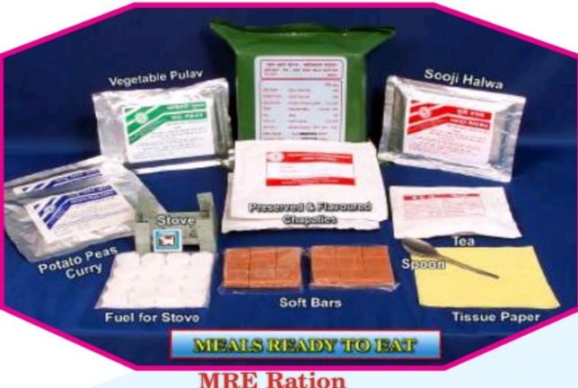 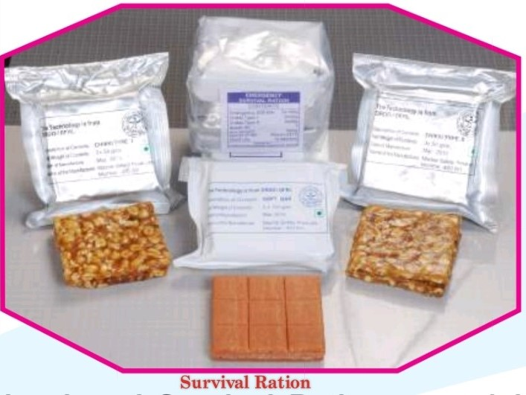

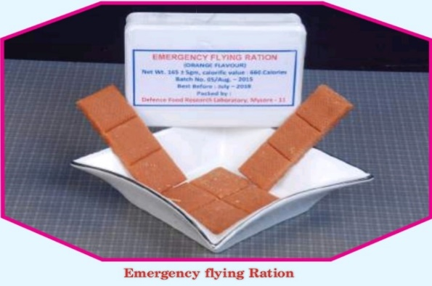

**POTABLE STERILIZED WATER POUCHES:**

Potable sterilized water pouches, is one of the main components of life support system in Personal survival Pack (PSP) of Indian Air Force.

**MOISTURE PROOF PACKAGING FOR SALT:**

Moisture proof salt packet is a part of Personal Survival Pack (PSP) of Air Force and the supply is limited to single source of supplier. From Foreign countries DFRL undertook the indigenous development of moisture proof salt packet.

**SEA DYE MARKER:**

The sea dye marker is a lifesaving item of Indian Air Force which is used to locate and rescue the air crew and other search vehicles during emergency. DFRL, Mysore is regularly supplying sea dye marker to Indian Air Force.

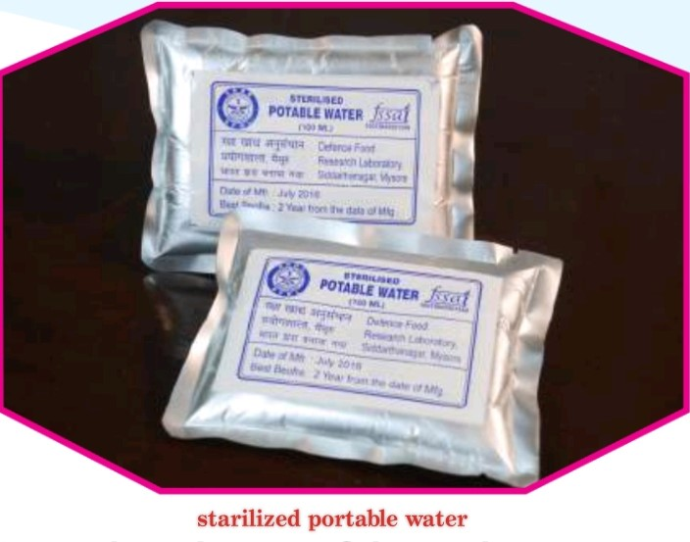 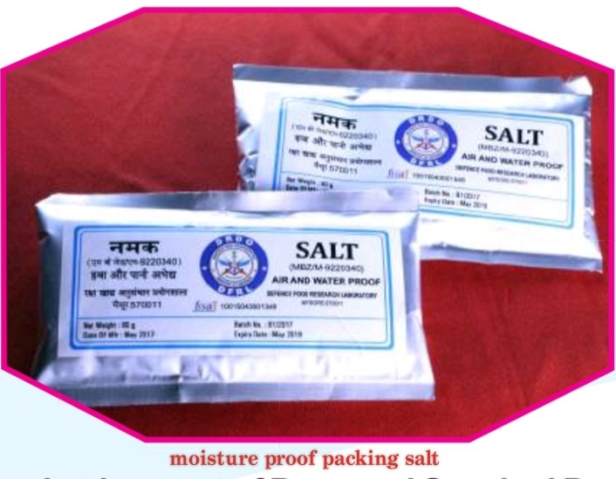

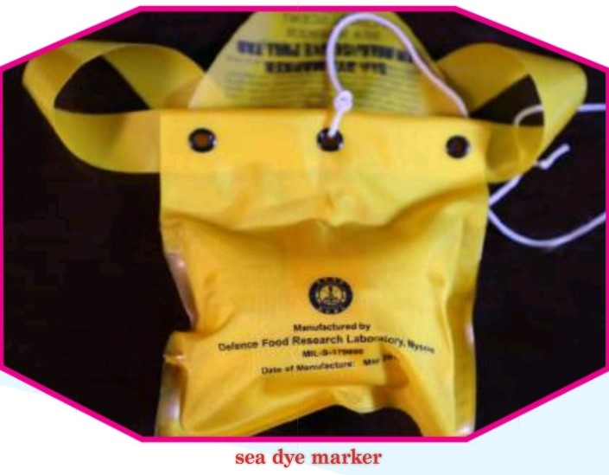

**DETECTION KITS**

**MILK TESTING KIT**

* Strip based method
* Detects added starch, urea, pulverized soap, detergents, hydrogen peroxide, boric acid, neutralizers and microbial freshness.
* Detects the quality of milk based on colour changes in the stripes.

**QUICK TEST KITS FOR PROCESSED FOODS**

* Developed for checking quality of processed foods.
* Based on the principal acid base titrations.
* The shelf life of the kit is six months and 125 samples used at ones in each kit.
* Developed for checking the quality dry rations: Alta, Suji, refined oils etc.
* Based on visual colour change.

**MEET TESTING KIT**

* Kit for testing microbial quality and differentiating cold and live slaughtered meet.
* Based on the principle dye reduction.
* Provides result within 10 to 30 minutes.

**PORTABLE FOOD MICROBIOLOGY LAB**

* Portable laminar air flow with UV light and Incubator for microbiological screening of fresh/ processed foods at field conditions.
* Contains: All-in-Bag- Ready to use homogenization filter bag for sample preparation, Ready to use culture media, Ready to use chromogenic test kits.
* Provides quick “positive or negative” result before the food product enters into the distribution system.

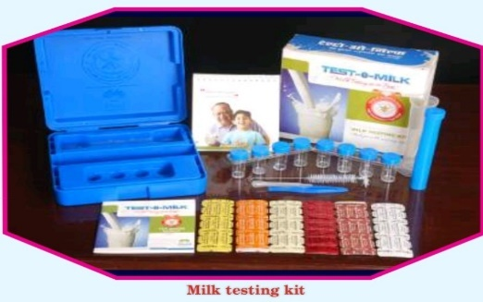 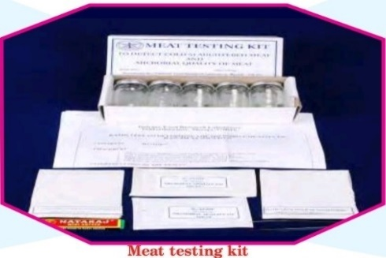

**BIODEGARADABLE CUTLERY**

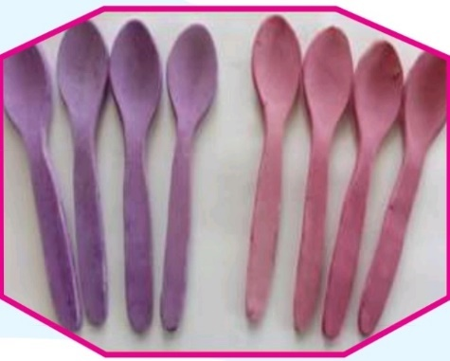 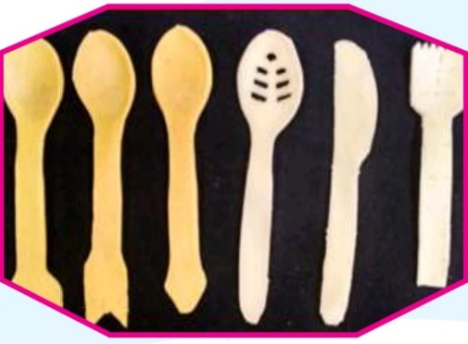

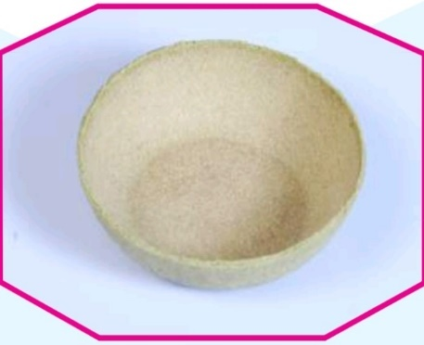

* Biodegradable cutlery available inform of spoons, folks, soup spoons, ice-cream sticks, bowls, kulhad and plates.
* Bio-composites degradable in environment are used in preparation of the biodegradable cutlery.
* Can be produced in varies texture and colour using different bio-composites and natural colours.
* Environment friendly and resistant to moisture for at least 30 minutes.

**BIODEGRADABLE FILMS FOR PACKAGING APPLICATIONS**

* Made up of environment friendly bio polymer.
* Fully bio-degradable (meeting ISO 17088).
* Converts to biomass by enzymatic degradation (within 180days).
* Easily manufactured by conventional blown films extrusion method.
* Can be stored at room temperature.
* Low density polyethylene (LDPE) is one of the most commonly used commodity plastic for food packaging application.

**MOBILE BSL-3 LABORATORY: PARAKH**

* ‘Parakh’ is a fully independent containment laboratory, built on ISO 20ft container and operated with negative pressure to handle clinical, food and environmental samples during biological emergency without any risks to workshop and environment.
* Provided with class three bio safely cabinet, RT-PCR, centrifuge, incubator, deep freezer and refrigerator.
* Provided with 15kva genset, UPS, demineralized water supply and decontamination facility for bio wastes.
* Deployed at Viral Research and Diagnostics Laboratory (ICMR-VRDL) of Mysore Medical college and Research institute (May 2020 to Feb 2021) to enhance the government’s testing capability.
* Useful for disease investigation on during pandemic/epidemic.

**FOOD PACKAGING AND DELIVERY SYSTEM FOR CBRN SCENARIO**

* Antioxidant rich foods fortified with vitamins and minerals and liquid meal delivery system to meet logistics requirements of CBRN environments.
* Paper based secondary packaged system to protect retort pouch processed food products of MRE rations during NBC conditions.
* Studied against live chemical warfare (CW) agent dispersed live microorganisms induced neutron radioactivity.
* No permeation of CW agents, no of microorganisms, no residual radiological activity - easy to decontaminate.
* Food product is safe for consumption after decontamination.

Ex: Secondary food packaging

**PRE-CUT AND PACKAGED VEGETABLES**

* Pre -cut vegetables in packed form to avoid kitchen drudgery.
* The products offer convenience and are highly suitable for specific end uses such as curries, salads, etc.
* The cut and packaged vegetables have a shelf life 4-8 days at ambient temperature and 4-6 weeks at low temperature.
* Minimal processing protocols for fourteen types of vegetables i.e., carrot, cauliflower, cabbage, potato, radish, capsicum etc.
* The additive based technology with nil to minimal use of heat processing, yields fresh-like products with long shelf life.
* The products as a result of inbuilt ability to withstand ambient temperature, offer marketing flexibility, under varied temperature conditions at the retail outlets.
* The energy saving technology is suitable for small scale/rural industry.

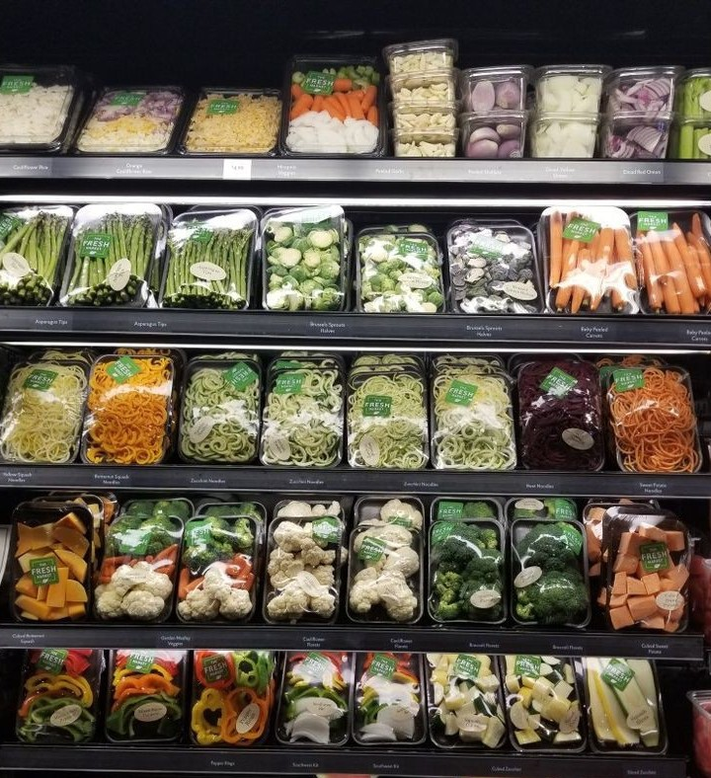

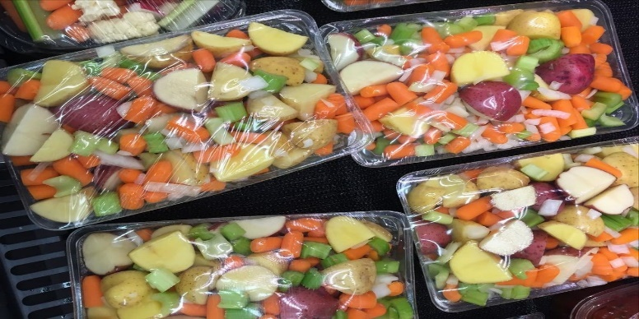

**INTERMEDIATE MOISTURE AND HURDLE TECHNOLOGY FRUITS**

* State -of – art technology for preservation of ready to eat fruits slices.
* Fruits with fresh like quality.
* Microbiologically safe and meeting quality standards.
* Suitable for cottage and small-scale industries.
* Storable in flexible packs without refrigeration.
* Shelf-life:6 months under ambient conditions.
* Osmo-drying is an excellent dehydration technology used for dehydration of fruits.
* In this process, the fruits slices are dehydrated partially by putting the, in concentrated sugar solution and partially by sun/hot air drying.
* The products retain their nutrition values to a greater extent in this process.
* The technology is highly suitable for several fruits including mango, papaya, pineapple, jackfruit, etc.

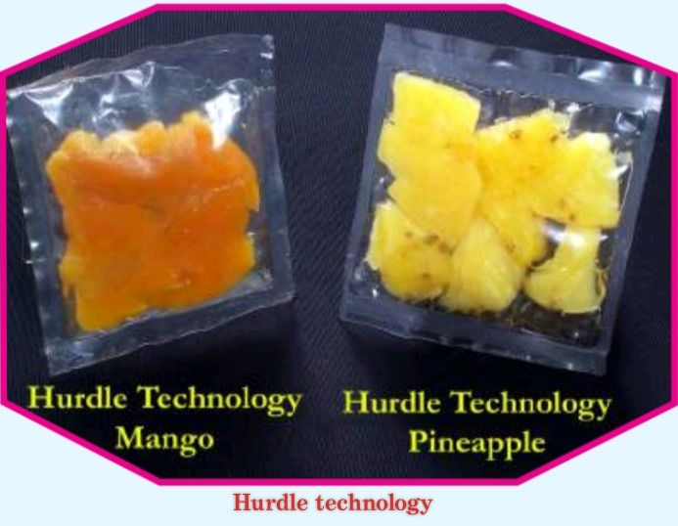 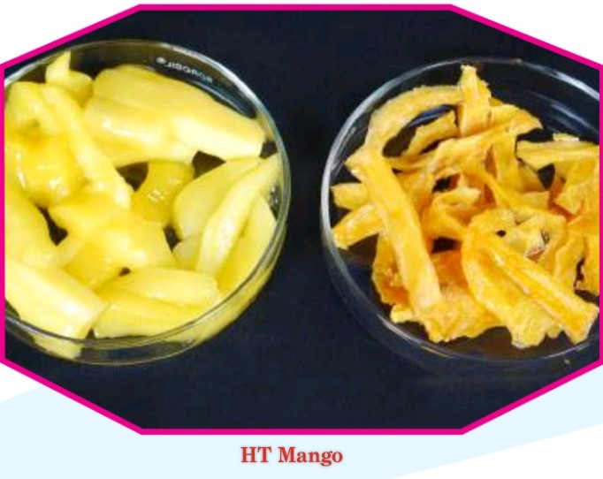

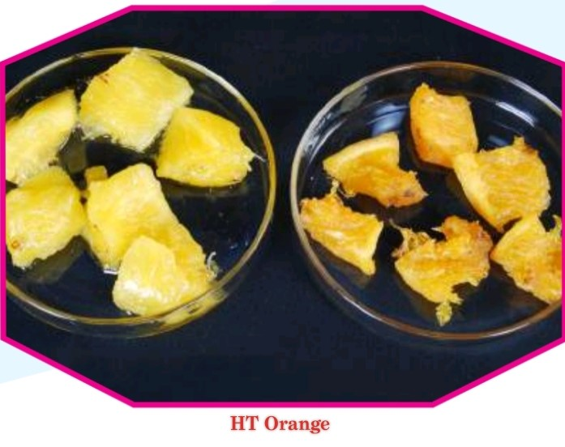 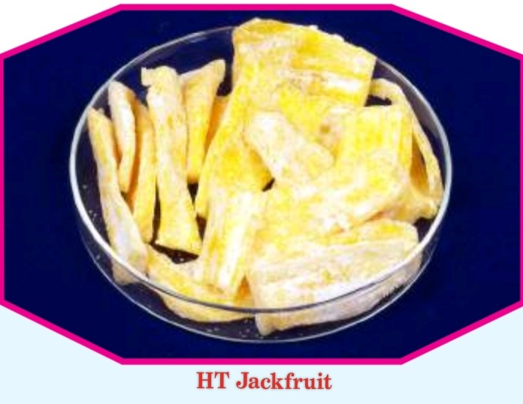

**READY-TO-DRINK AND READY TO RECONSTITUTE JUICES AND BEVERAGES**

* Pleasant color, flavor, aroma and taste
* Natural health drink, rich in vitamins, minerals and antioxidants
* Light in weight and readily rehydrated hot and cold water
* Long shelf -life ambient condition

Aloe passion drink: Anxiety is debilitating state of mind, it has emerged to be a common psychiatric manifestation of modern-day lifestyle.

Tender coconut: Fruit juice blended tender coconut water is a delicious health drink and can be highly useful for purpose and also as a hospital-based beverage besides catering to the requirements of sports including rallies and expeditions.

Brahmi drink: It is an anti-fatigue and neuroprotective was developed from the herb Bacopa Monera.

Various ready to reconstitute and ready to serve fruit juices and functional juice mixes were developed based on FD technology like Aloe passion drink, Tender coconut water, Brahmi drink, Ash gourd Beverages, sweetened Beetroot juice, Mango juices powder, pineapple juice powder, grape juice powder, mango shake powder, carrot muskmelon juice powder, high protein pineapple lassi powder, etc.,

The products are stable up to one year below 35.0% relative humidity. Product can be reconstituted and prepared instantly by adding 150ml of water to 30g of freeze-dried juice powder/beverages.

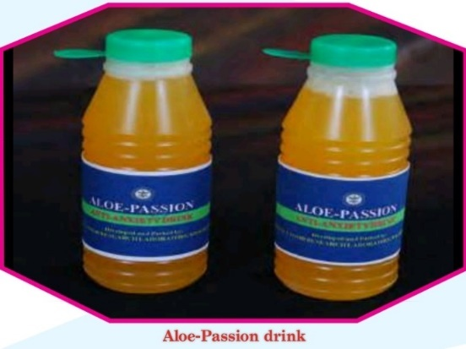 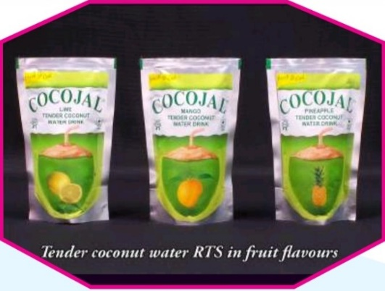

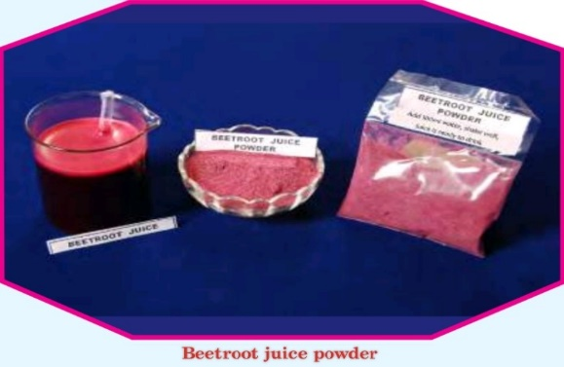 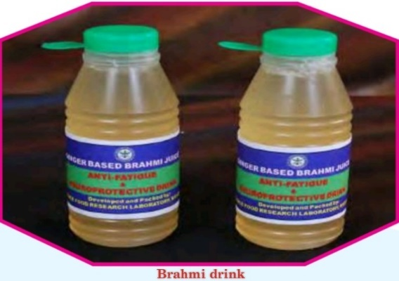

**READY TO RECONSTITUTE FOOD PRODUCTS**

* Multiple varieties of food products
* Instant rehydration (2 to 5 minutes) on addition of hot water
* Developed by cold shock dehydration and combination processing technology
* Retains original colour and flavors upon reconstitution

Instant Sooji halwa: Halwa made from sooji (semolina) and sugar and further embellished with cashew kernels and flavours is a very popular dish of Indian dietary. It’s rich roasted flavour and excellent taste.

Instant Idli sambar: Idlis are highly traditional south Indian delicacy relished all over the country, should be consumed within the same day of preparation.

Instant upma mix: The mix is reconstituted by simmering in water and bringing the ingredients to a boil with occasion, the product can be served hot within four minutes of its reconstitution and provide the consumer with all the characteristics taste and flavour.

Instant vegetable pulao: DFRL has developed the instant cooking rice by pressure cooking and conditioning to particular moisture content, flaking to a specified thickness and drying ina through flow dryer such that it retains porous structure with low density which helps in faster rehydration during reconstitution.

Instant carrot halwa, Instant rave Idli mix, Instant Upma mix, Instant Vermicelli Kheer mix, Instant Idli mix, Instant chutney mix, Instant vegetable pulao mix, Instant Coley mix, Instant rice kheer/porridge mix, Instant fibre rich bisibelebath, Instant spiced dal.

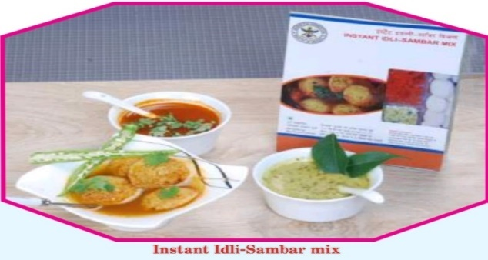 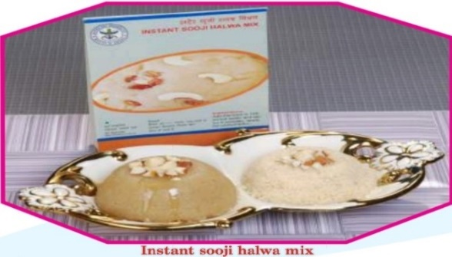

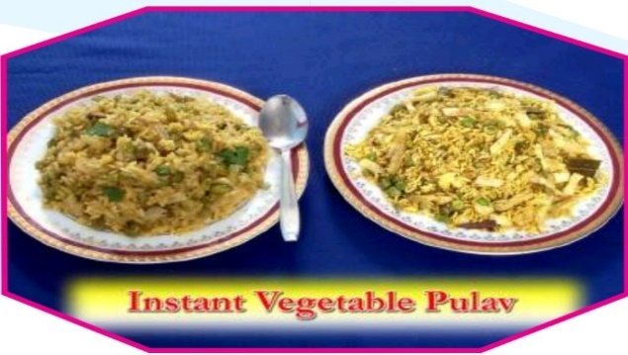 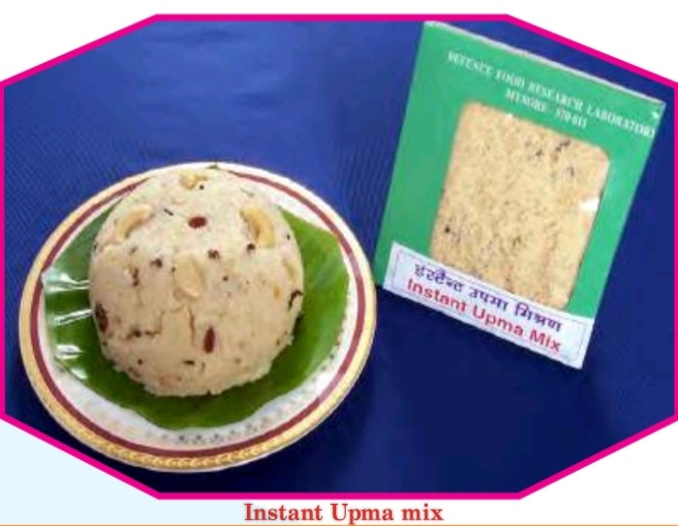

**READY TO RECONSTITUTE FOOD PRODUCTS (FREEZE DRIED)**

* Freeze dried products include various instant mixes, juice powders, beverage mixes and whey protein enriched pineapple powder, which combine the health benefits of fruit and dairy components.
* Products are light in weight and thirst quenching
* Maximum retention of nutrients and bioactive components
* Shelf-life: More than a year at ambient condition
* Superior in terms of task, flavour and overall-acceptability compared to other dehydrated products.
* Suitable for logistics requirements
* Instantly rehydratable in cold/normal water.

FD Grapes, FD Mango, FD Curd, FD chicken pulao, FD Pineapple.

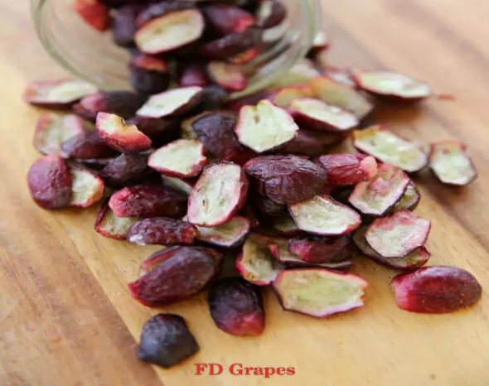 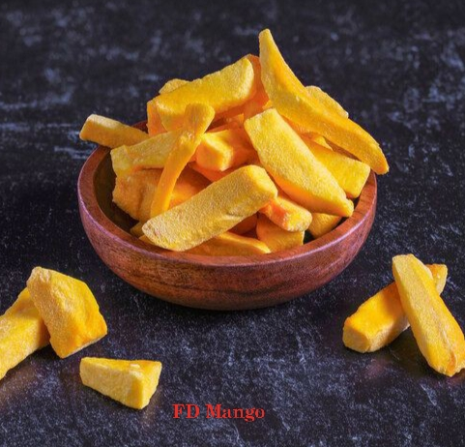

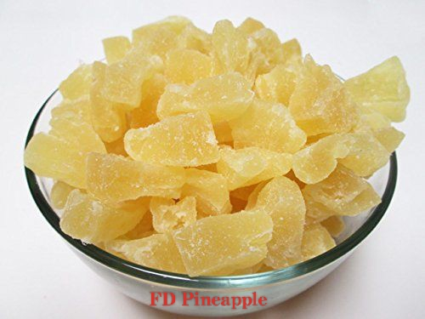

**READY TO EAT CHAPATIS/PARATHAS AND KATTI ROLLS**

* Chapatis /Parathas (No preservative) and Katti rolls (veg and non-veg) were developed by retort processing technology.
* Katti rolls can be consumed as such without any adjuncts.
* Katti rolls meet the requirement of wholesomeness of chapatis and juices of vegetables and meat products.
* Products are soft in texture and palatable.
* Ready -to-eat and nutritious.
* Provides 235-280Kcal.

RTE chapati, RTE Paratha, RTE Katti rolls, egg rolls, chicken rolls, Green leafy vegetable paratha.

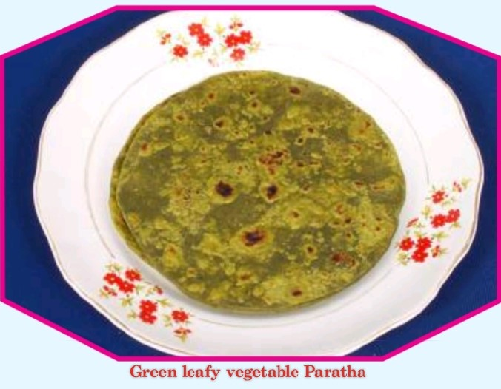 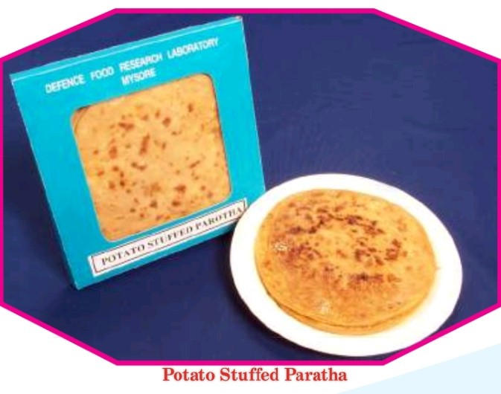

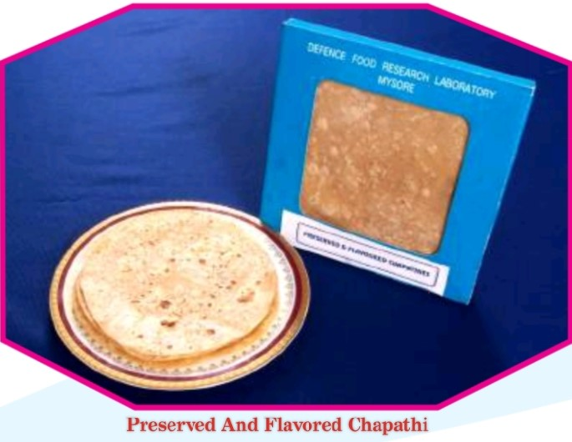 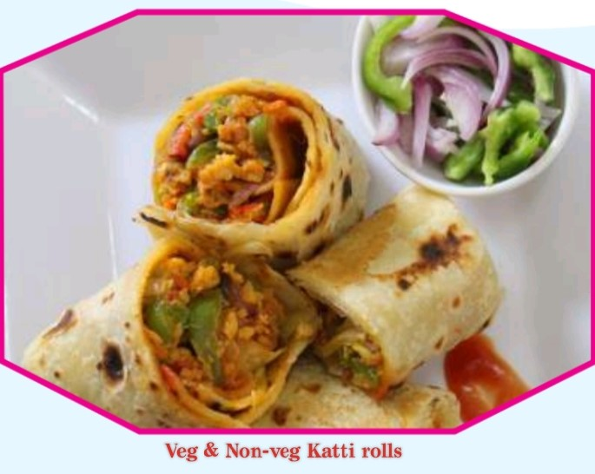

**READY TO EAT BARS**

* Different varieties of RTE bars to provide adequate energy and nutrients.
* Contains various functional ingredients.
* Light in weight and highly palatable.
* Can be used as emergency/survival ration.
* Provides 400-540Kcal/100g.
* Developed bars with soluble and insoluble fibres using barley grains as well as oat and wheat brans to provide high fibre content.
* The energy bars provide all essential amino acids in a balanced amount and rich in protein, light weight, easy to carry and provides sufficient energy during emergency and survival situations.
* The bars can be used as a substitute for food containing non vegetarian source of fatty acids.

Omega-3-Rich Bar, Chicken Bar, Tulsi Bar, High energy Bar, Choco whiz Bar, Beet root Bar, Albumin Based Bar, Barley and fibre enriched Bar, Groundnut Burfi, composite cereal Bar, egg protein biscuits, Moong dhal Burfi etc.

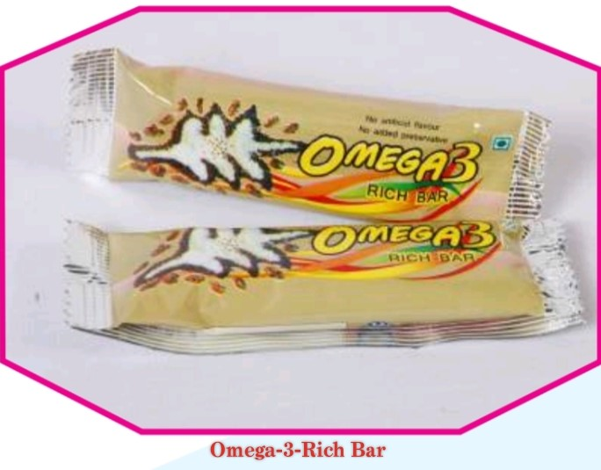 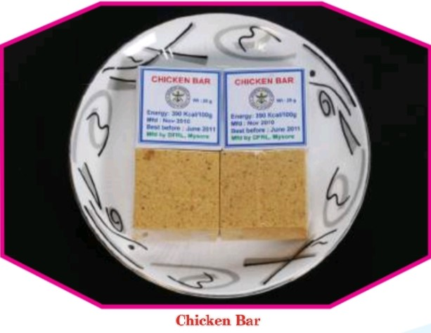

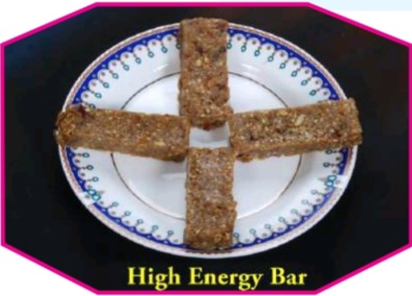 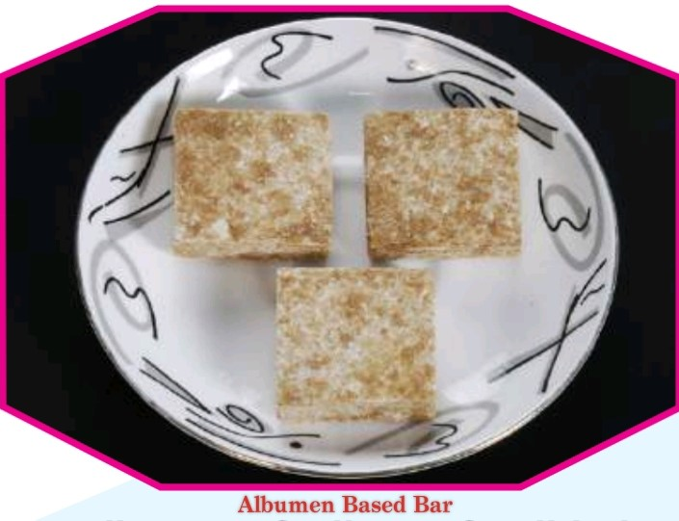

**RATIONS FOR DEFENCE FORCES**

**PERSONAL SURVIVAL PACK (PSP) PRODUCTS**

* Main components: survival ration, potable stabilized water pouches, moisture proof packaging salt, sea dye marker.
* Rations were packed in 165g and 50g.
* Shelf-life: PSP items (Air force).
* Shelf-life: Survival Ration-soft bars, chikki (Army).
* See dye marker is a lifesaving item used to locate and rescue for air crew and other search vehicles during emergency.
* Fluorescent green dye dissolves in water within 5 minutes spread over the surface and bright green patterns remains in sea water for more than 45 minutes and visible at a distance of 10 miles from an altitude of 3000 feet.

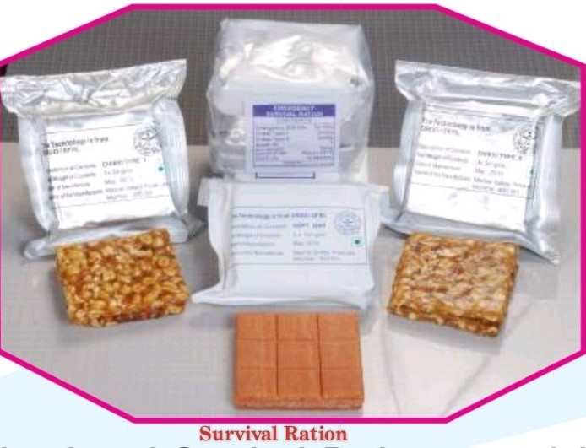 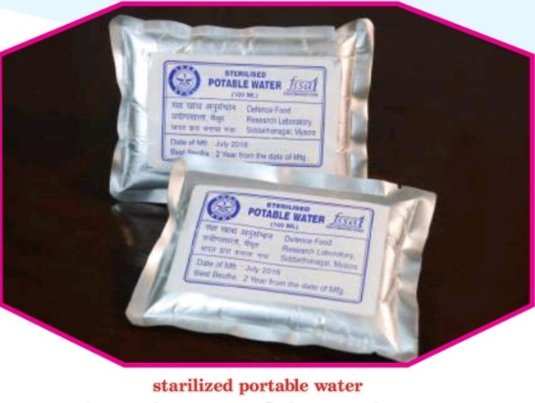

 

**RATIONS FOR DEFENCE FORCES**

**TERRAIN SPECIFIC MRE’S**

* Meets operational and logistics requirements.
* Provides safe, tasty and convenience food with adequate nutritional value.
* Based on retort pouch processing technology with multi-layer packaging system
* Shelf life-one year.
* Both vegetarian and non-vegetarian menu.
* Used by Army and para-military forces.

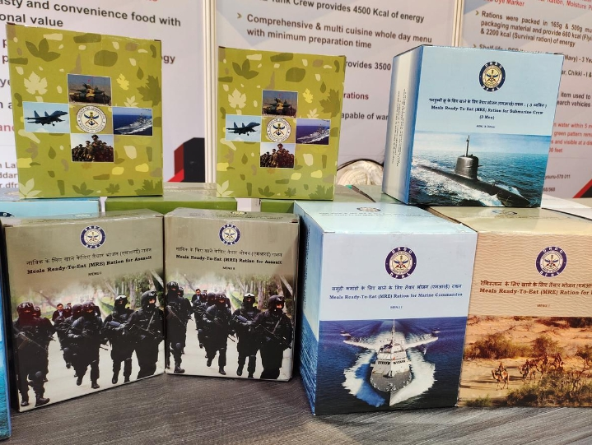

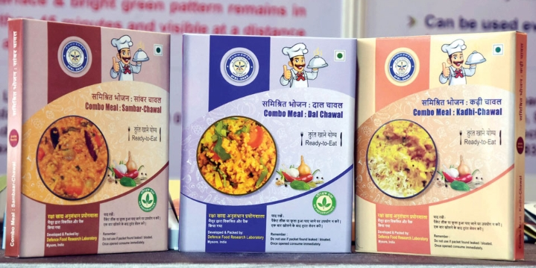

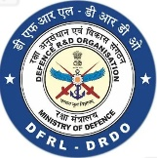

FORCE BEHIND FORCES – DFRL

To develop nutritionally balanced combat ration and to provide victual support system by adapting state-of-the-art technologies to meet operational requirements of service forces and be a referral laboratory for quality assurance and safety besides training and spin off applications.

**CHAPTER OF DUTIES**

Research And Development of Advanced Food Technology for Mission, Platform, And Environment Specific Ration

Development Of State-of-the-Art Food Packaging Technologies for All Environment

**CONCLUSION**

In our college arranged one day visit to the Defence Food Research Laboratory (DFRL), Mysore to the students for the internship. As we are all visited their and learn lot of things about DFRL, we learn about various aspects of food science and technologies such as the development of convenience foods, preservation of foods, nutritional and biochemical evolution, food safety and food packaging. The DFRL at Mysore especially to cater to the strategic operational requirements of our services and to provide logistical support for food supplies and varied food challenges of Indian Army, Navy, Air Force and other Paramilitary Forces.

We learned how they prepared and packed foods for the Defence Forces on the basis of temperature condition, feezed condition and live for long time using new technologies and learns about the various types of food preservation for Defence Forces. It was really a good opportunity for us to learn about this type of food research laboratory, I have learned so much of things about this laboratory, I am particularly inspired by the various research about foods. I would like to express my special thanks of gratitude to my professor to give me this opportunity to gaining a knowledge about the Defence Food Research Laboratories.